April Nixon

Southern New Hampshire University

**7-2 Project Two Submission**

Professor Kalysa Wilson

February 20, 2024

**Introduction**

In the ever-evolving landscape of software development, the importance of rigorous testing methodologies cannot be overstated. As a software engineer at Grand Strand Systems, I recently completed Project One, which involved developing a mobile application with specific features such as contact, task, and appointment services. This task presented a unique opportunity to dive deep into the realm of unit testing, leveraging JUnit to ensure the application not only met the specified requirements but also adhered to the highest standards of quality and reliability. This summary and reflections report aims to outline my approach to unit testing, the experience and insights gained through writing JUnit tests, and the broader implications of testing strategies in software development practices.

**Summary and Reflections Report**

The unit testing strategy for the three features in the project was crafted to align with the explicit software requirements. For each feature—contact, task, and appointment services—I developed a suite of tests that scrutinized every aspect of the functionality, from input validation to behavior under various conditions. The contact service, for example, required a nuanced approach to testing, ensuring attributes like contact ID uniqueness, length constraints for names and addresses, and the specific format for phone numbers. This testing regime was crucial in affirming the alignment of my approach with the overarching software requirements.

The quality of my JUnit tests was substantiated by the comprehensive coverage achieved, indicating a thorough examination of the application's functional landscape. This was accomplished through a combination of direct testing of features and validation of edge cases, thereby ensuring a robust defense against potential defects.

In Project One for Grand Strand Systems, my approach to unit testing for the contact, task, and appointment services was methodical and rigorous, aimed at ensuring the software met all specified requirements. I designed tests to validate each feature comprehensively, focusing on the critical aspects such as input validation, functionality, and edge cases. For instance, in the contact service, tests were crafted to confirm that contact IDs were unique, not exceeding 10 characters, non-null, and immutable. Similar diligence was applied to first and last names, phone numbers, and addresses, ensuring adherence to the predefined constraints.

My testing approach was closely aligned with the software requirements. Each test case was developed with the specific objective of verifying the implementation against its requirements. For example, I wrote tests to verify that phone numbers consisted exactly of 10 digits and that the address field did not exceed 30 characters, directly reflecting the specifications.

The effectiveness of my JUnit tests is evident from the high coverage percentage achieved, which indicates a broad assessment of the code's functionality. By covering various scenarios, including both typical use cases and potential error conditions, my tests ensured a robust verification of each feature's implementation.

Writing the JUnit tests was a learning experience that deepened my understanding of unit testing's role in software quality assurance. To ensure technical soundness, I focused on testing each class's critical functionality. 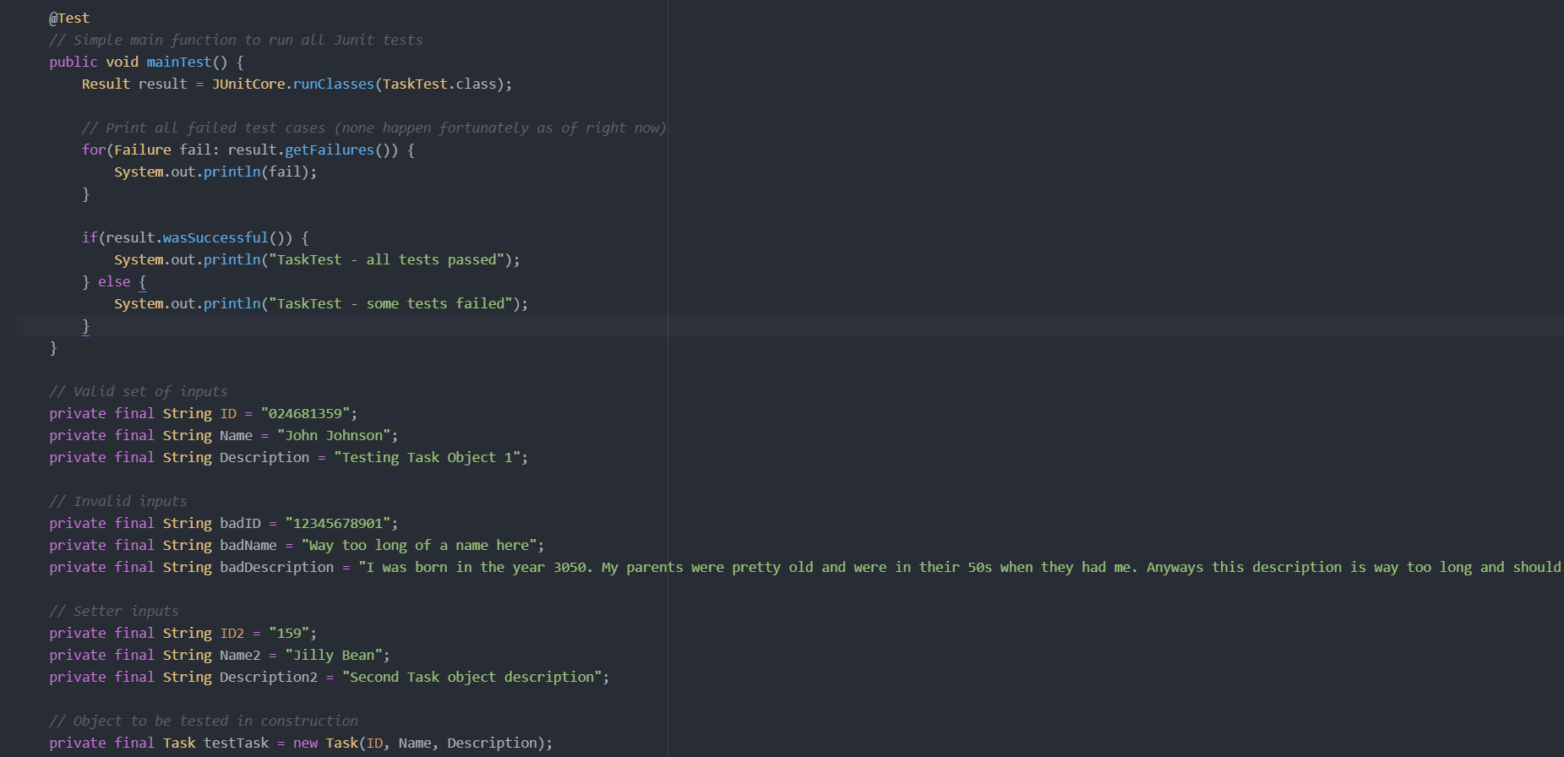

For instance, these lines check for the validity of the ‘Task ID’. The ‘badID’ string exceeds an implied maximum length of 10 characters, and the expectation set by ‘rule.expect(AssertionError.class)’ suggests that creating a Task object with an ID longer than this limit should throw an assertion error, enforcing a length constraint. The purpose here is to ensure that the ID adheres to a specific format or length requirement, which is crucial for maintaining consistent data integrity and possibly for interfacing correctly with other systems or database schemas. 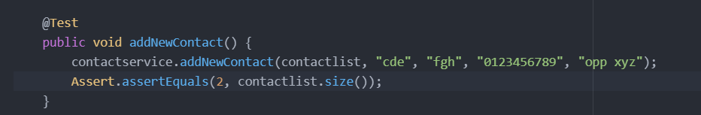

For instance, in the snippet of my unit test, I've demonstrated efficiency by directly invoking the method ‘addNewContact’ from the ‘contactservice’ with the required parameters. This single, concise line of code effectively adds a new contact to ‘contactlist’ without the need for any setup or additional processing. Also, I employed a straightforward assertion to validate the outcome, ‘Assert.assertEquals(2, contactlist.size())’, which checks if the list size is as expected after the addition. This assert is a clear indication that I'm not only testing the functionality but also ensuring the correctness of the operation with minimal lines of code. The test is focused, there's no redundancy, and every line of code serves a direct purpose towards the test goal, reflecting my ability to write tests that are both effective and economical.

Therefore, writing the JUnit tests was an educational experience, enhancing my understanding of the critical role that testing plays in software development. Specific lines of code, such as testing for exceptions when inputs exceeded defined limits, exemplified my commitment to technical soundness and efficiency.

**Testing Techniques**

The project leveraged dynamic testing techniques to evaluate the application's behavior in real-time, which was instrumental in identifying runtime issues and validating the functionality across different scenarios. Although static testing was not explicitly used, its principles guided the initial code review process, helping to identify syntax errors and enforce coding standards from the outset.

The juxtaposition of dynamic and static testing displays the multifaceted nature of software testing, where each technique serves distinct purposes. Dynamic testing offers insights into the application's operational performance, whereas static testing can preemptively address potential issues, streamlining the development process.

**Mindset**

Adopting a meticulous and cautious mindset was important when navigating the complexities of the project. Appreciating the intricate relationships between different components of the application informed a more holistic testing strategy, displaying the importance of a comprehensive understanding of the system.

Efforts to minimize bias, such as through peer reviews, were essential in ensuring an objective assessment of the code. Recognizing the potential for bias in self-review was also an important step in maintaining the integrity of the testing process.

The discipline in adhering to high-quality standards highlights the ethical responsibilities of a software engineer. Avoiding shortcuts and maintaining a steadfast commitment to rigorous testing practices are fundamental in mitigating technical debt and ensuring the long-term success of the application.

**Conclusion**

The completion of Project One at Grand Strand Systems was not just an exercise in software development but a learning journey in the art and science of software testing. Through the application of dynamic testing, meticulous planning, and a disciplined approach to quality assurance, the project displayed the importance of unit testing in the development lifecycle. As I move forward in my career, the insights and experiences gained from this project will serve as a guiding beacon, emphasizing the necessity of rigorous testing methodologies, the value of a critical mindset, and the uncompromising commitment to software quality. In the realm of software engineering, where the stakes are perpetually high, such principles are not merely beneficial—they are indispensable.

**References**

Basili, V. R., & Selby, R. W. (1987). Comparing the effectiveness of software testing strategies. *IEEE transactions on software engineering*, (12), 1278-1296.

Deak, A. (2014). What characterizes a good software tester?–a survey in four norwegian companies. In *Testing Software and Systems: 26th IFIP WG 6.1 International Conference, ICTSS 2014, Madrid, Spain, September 23-25, 2014. Proceedings 26* (pp. 161-172). Springer Berlin Heidelberg.

Do, H., Rothermel, G., & Kinneer, A. (2004, November). Empirical studies of test case prioritization in a JUnit testing environment. In *15th international symposium on software reliability engineering* (pp. 113-124). IEEE.

Eldh, S., Hansson, H., Punnekkat, S., Pettersson, A., & Sundmark, D. (2006, August). A framework for comparing efficiency, effectiveness and applicability of software testing techniques. In *Testing: Academic & Industrial Conference-Practice And Research Techniques (TAIC PART'06)* (pp. 159-170). IEEE.

Krantz, M., Zhang, H., & Zhu, J. (2009). Characterization of powder flow: Static and dynamic testing. *Powder Technology*, *194*(3), 239-245.